Fractions

Adding or subtracting like fractions
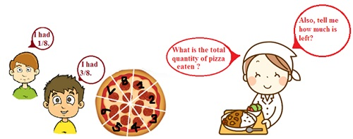
Addition of Like Fractions
- Since like fractions have the same denominator, we retain the denominator in the final answer.
- We add the numerator to get the numerator of the final fraction.
Subtraction of Like Fractions
- Since like fractions have common denominator, we retain the denominator in the denominator.
- The numerators are subtracted to get the numerator of the final fraction.

Problem: Solve: 1/18 + 1/18
Solution:
- The fractions have a common denominator.
- The denominator of the value 18 is retained.
- The numerators are added to get the numerator of the final fraction. The sum of the numerators is: 1+ 1 =2.
- Hence, the final fraction is 2/18.

Problem: Solve: 7/7 - 5/7
Solution:
The fractions have a common denominator.
The denominator of the value 7 is retained.
The numerators are subtracted to get the numerator of the final fraction. The subtraction of the numerators is: 7-5 =2.
Hence, the final fraction is 2/7.

Problem : Peter was given 5/7 of a basket of balls. What fraction of balls was left in the basket?
Solution:
Let the total number of balls be = 1
This can be written as 7/7 also since 7/7 =1.
The fraction of balls given to Peter = 5/7
The fraction of balls left in the basket = Total number of balls – Fraction of balls given to Peter
= 1- 5/7
We can write 1 as 7/7 as this would convert both fractions into like fractions.
= 7/7 -5/7
= (7-5)/7
= 2/7
Thus, the fraction of balls left in the basket is 2/7.

